The Implications of Airbnb’s Lack of Regulations

Cade MacLean, Josh Pollak, and Raghav Arora

California Polytechnic State University, San Luis Obispo

Dr. John Dobson

29 November 2020

**Background of Airbnb:**

Airbnb began in 2008 when two designers who had space to share, hosted three travelers looking for a place to stay. Now, millions of hosts and travelers choose to create a free Airbnb account so they can list their space and book unique accommodations anywhere in the world. And Airbnb experience hosts share their passions and interests with both travelers and locals (Airbnb, 2020). The company was founded by Brian Chesky, Joe Gebbia, and Nathan Blecharczyk in San Francisco during 2008 where they became one of the first to peer-to-peer services that specialized in housing accommodations. The founders were traveling to a conference in 2007 but couldn’t pay for their housing, so two of the founders decided to rent out part of their apartments in order to help pay for the cost of the trip. This sparked their idea. The founders wanted to change the way that people thought about travel. In 2009 they partnered with Y Combinator and expanded its limited offerings. They continued their expansion and capital raising efforts to eventually grow its operations internationally by acquiring Accoleo (Woodpress, 2020). Airbnb is an online marketplace that connects people who want to rent out their homes with people who are looking for accommodations in that locale. It currently covers more than 81,000 [cities](https://www.investopedia.com/articles/small-business/020217/investors-5-best-and-worst-cities-airbnb-renting.asp) and 191 countries worldwide (Investopedia, 2020).

**Problem Definition:**

The Airbnb business model consists of a peer-to-peer exchange of services where transactions and responsibilities are carried out exclusively by hosts and guests, limiting Airbnb’s liability entirely. Sharing economy platforms like Airbnb are relatively new, and due to imperfect information and lack of knowledge, they are not yet regulated properly.

The weakness of current regulations has allowed Airbnb to impact business, government, and society in several ways. The three key problems analyzed in this paper using real world case studies include overall disruption of residential neighborhoods, rising rent gaps, and hotels along with other large entities using Airbnb to evade taxes. Therefore, we believe Airbnb should be subject to more regulation to mitigate its negative business, societal, and governmental impacts. Moreover, this poses an ethical dilemma of whether Airbnb should be regulating themselves to help suppress the problems that have arisen. Throughout the paper, different behavioral finance terminology, financial ethics dilemmas, and outside coursework reading will be evaluated in the context of Airbnb to further the point that Airbnb should be subject to greater regulations.

**Social Issues:**

The primary social implication present is that Airbnb rentals have the potential to disrupt residential neighborhoods. There have been many cases of Airbnb rentals turned to party houses, as well as a massive increase in tourists in residential areas. Specifically, in Brixton, London, riot police were called to an Airbnb after more than 150 people showed up for a party that turned to chaos. This was not an isolated issue; residents had called the police on several different occasions to break up parties (Dean, 2016). Unfortunately, disturbances like these are not an uncommon occurrence with Airbnb rentals, and there have been similar instances within cities across the United States.Although Airbnb does give travelers many benefits, other stakeholders such as local residents can reap the negative consequences. Naturally, people who are only visiting a place for a couple of days are less likely to care about the long-term quality and sense of community in a neighborhood. Noise disturbances, parking shortages, and other nuisances can ultimately affect the quality of a neighborhood.

*Image 1 (Marcelle, 2019)*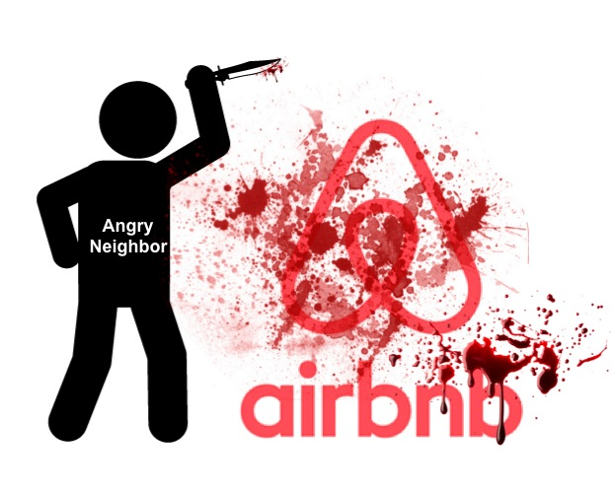

One of the major ethical theories related to this issue is John Rawl’s Veil of Ignorance. Present since the eighteenth century, the “veil of ignorance” is a method of determining morality. This theory basically tries to develop a new social contract for the world, given that a person does not know their social position in society. In this theory, a person has to make a decision about a social/moral issue assuming they have enough information to know the consequences of their decisions for everyone (OriginalPosition, 2020). The main ethical dilemma in the article arises due to temporary Airbnb guests trashing the host's house while also disrupting the surrounding neighborhood, with Airbnb facing no liability for their guest’s actions. The consequence of this moral issue leads to damage to neighborhoods, both physically and economically. This situation presents the world with two different types of groups, guests/hosts and Airbnb/neighbors. In the guest and host relationship, liability is accounted for, as the guest has to pay the host for any damages and the host has to pay the guest for any inconveniences. However, with regards to the Airbnb and neighbor relationship, liability is not accounted for. Any damage done to the neighborhood or to the psyche of neighbors goes unnoticed. The neighbors would deem this to be morally wrong, while Airbnb would deem this to be morally right as it saves them money. However, with regards to Rawl’s “veil of ignorance”, if a person’s position in society would be chosen at random, making them either an affected neighbor or an Airbnb executive, then most people would force Airbnb to be accountable for their guest’s actions, thus deeming this scenario to be morally wrong and a socially unjust practice. Therefore, it is vital that Airbnb is regulated further, so that they can be held accountable for the damages caused by their guests.

Furthermore, the negative social impact of Airbnb is also related to the public's investment strategy with regards to emotional bias. Emotional bias refers to a distortion in cognition and decision making due to emotional factors. Emotional biases typically occur spontaneously based on the personal feelings of an individual at the time a decision is made. They may also be deeply rooted in personal experiences that also influence decision making. Emotional biases are usually ingrained in the psychology of investors (Parker, 2020). If Airbnb is consistently linked to disrupting neighborhoods and failing to account for their liabilities, they will develop a negative public image, one that is ingrained in the mind of investors. Investors will be less likely to invest in Airbnb as the company would seem unethical. Furthermore, people who have been directly affected by neighborhood disruptions due to an Airbnb listing, would stray away from investing in the company even further. Thus, for its own good, Airbnb should regulate themselves better, in order to have a positive brand image, one that the public would like to invest in.

*Image 2 (Barbara, 2016)*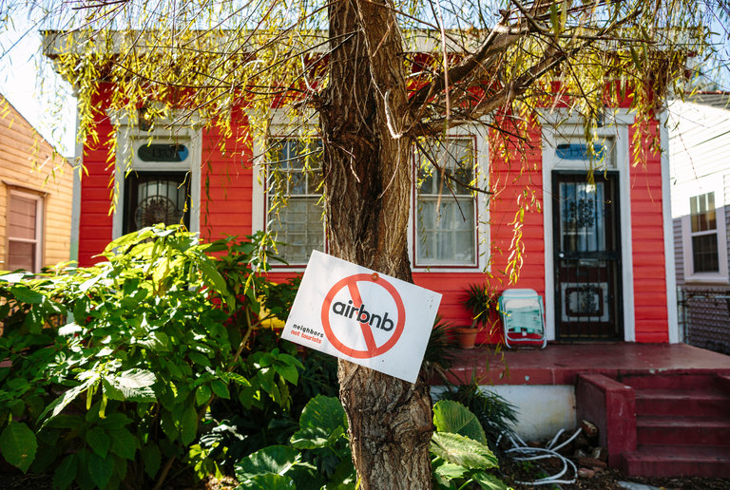

The goal for Airbnb should be to shift from the Shareholder Value theory to adopting the principles of Corporate Social Responsibility. In the article “The truth about CSR”, Rangan mentions that the main goal of a company should be to align its social and environmental activities with its business purpose and values. Moreover, they should contribute to the well-being of the communities and society they affect and on which they depend (Rangan, 2015). Airbnb, being a world-wide sharing economy platform, affects the lives of many stakeholders. These include guests, hosts as well as the neighbors near any Airbnb listing. By causing disruptions such as noise pollution, parking shortages etc. Airbnb is negatively affecting the lives of its neighbors and bringing the quality of the neighborhood down. Moreover, Airbnb faces no repercussion for such actions as its liability is limited. In doing so, though Airbnb is cutting costs and maximizing wealth for its shareholders, it is not adhering to the principles of CSR, as it is ignoring the social and environmental impact of its listings. Therefore, it is vital for Airbnb to regulate themselves better and take accountability for its actions in order to become a socially responsible corporation.

**Business and Economic Issues:**

With over 14,000 new hosts per month and over 7 million listings globally it is safe to say that Airbnb is quickly growing and expanding, taking away business from their direct competitors. Airbnb has revolutionized the renting and traveling market with their low costs, convenient locations, and household amenities. Despite all of these positives, it is leaving a lasting impact on the housing market as a whole. With the convenience of short-term rentals and the profitability behind it, there has been a trend of landlords shifting their focus from long-term consumption to more of a short-term approach. With this change in focus from landlords, a downhill effect on the renting market has emerged. As landlords shift to a short-term mindset, it is creating a decrease in the supply of long-term housing for the local community, which in turn inflates the prices of renting.

This new lens that landlords have adopted falls right into the idea of act utilitarianism. Act utilitarianism is a utilitarian theory of ethics which states that a person's act is morally right if and only if it produces the best possible results in that specific situation. Airbnb as an organization is looking past the negative impacts their business model is having on different stakeholders and focusing on the end results. Airbnb is justifying their moral behavior by the results they generate with regards to profit and revenue. They are acting on behalf of what is going to generate themselves the greatest profit not only for the landlords but also for themselves. The landlords know how profitable it can be to shift their property to an Airbnb listing rather than a long-term rental and are making a change solely off of the fact that they will walk away with more money. When people act with this mindset of trying to achieve the best possible financial results, they can lose sight of reality. For example, the shift from long-term to short-term renting comes with some external cost and logistical issues that many people may fail to see. To run an effective Airbnb listing and maximize the most use of their property, many people will hire a property manager to run the logistics. With a property manager comes increased costs that most people would normally not factor into their decision-making process when deciding the best use for their real estate. According to Airbnb, a property manager of a listing on Airbnb will assume 20% of the overall price of the listing (Airbnb, 2020). Not only that, but when you factor in cleaning fees and utilities and appliances, these costs start to accumulate. With the landlords making decisions in the act utilitarianism framework, they are failing to see some of the underlying cost that could result in a smaller profit for them. Having said this, the shift to more Airbnb listings is creating this ethical dilemma for hosts about whether to act on what appears to make them the most money or to act on what is best for the society.

This new shift to more short-term rentals has been seen across the globe in recent years. Major cities across the U.S. have observed significant changes directly attributable to Airbnb with regards to rental rates and housing prices. For example, New York neighborhoods such as Manhattan’s Hell Kitchen and the Midtown Business District have seen increases in rental rates of $398 from 2009 to 2016. 21.6% of this increase is a direct result of the increases in Airbnb listings (Ferré-sadurní, 2018). Moreover, a study from the Harvard Business Review found a causal association between Airbnb listings and rental rates in Boston. After analyzing data regarding Airbnb and the U.S. real estate market the following association was found; for every 1% increase in Airbnb listings there is a 0.018% increase in rentals rates and a 0.026% increase in housing prices (Barron, 2019). While these effects seem small, Airbnb’s annual average growth is 44% (Barron, 2019). Thus, in aggregate, Airbnb contributes to about one-fifth of the average annual increase in U.S. rents and about one-seventh of the average annual increase in U.S. housing prices. This can further be seen graphically in the Figure 1 below. If we take Greenpoint and Williamsburg for example, one can observe the severe impact Airbnb is having on the monthly rent in New York City. Over the spread of 2009 to 2016, Airbnb has caused monthly rent to inflate by a factor of $123 or just over 18.6%. As a result, local residents see an increased cost of living that would be 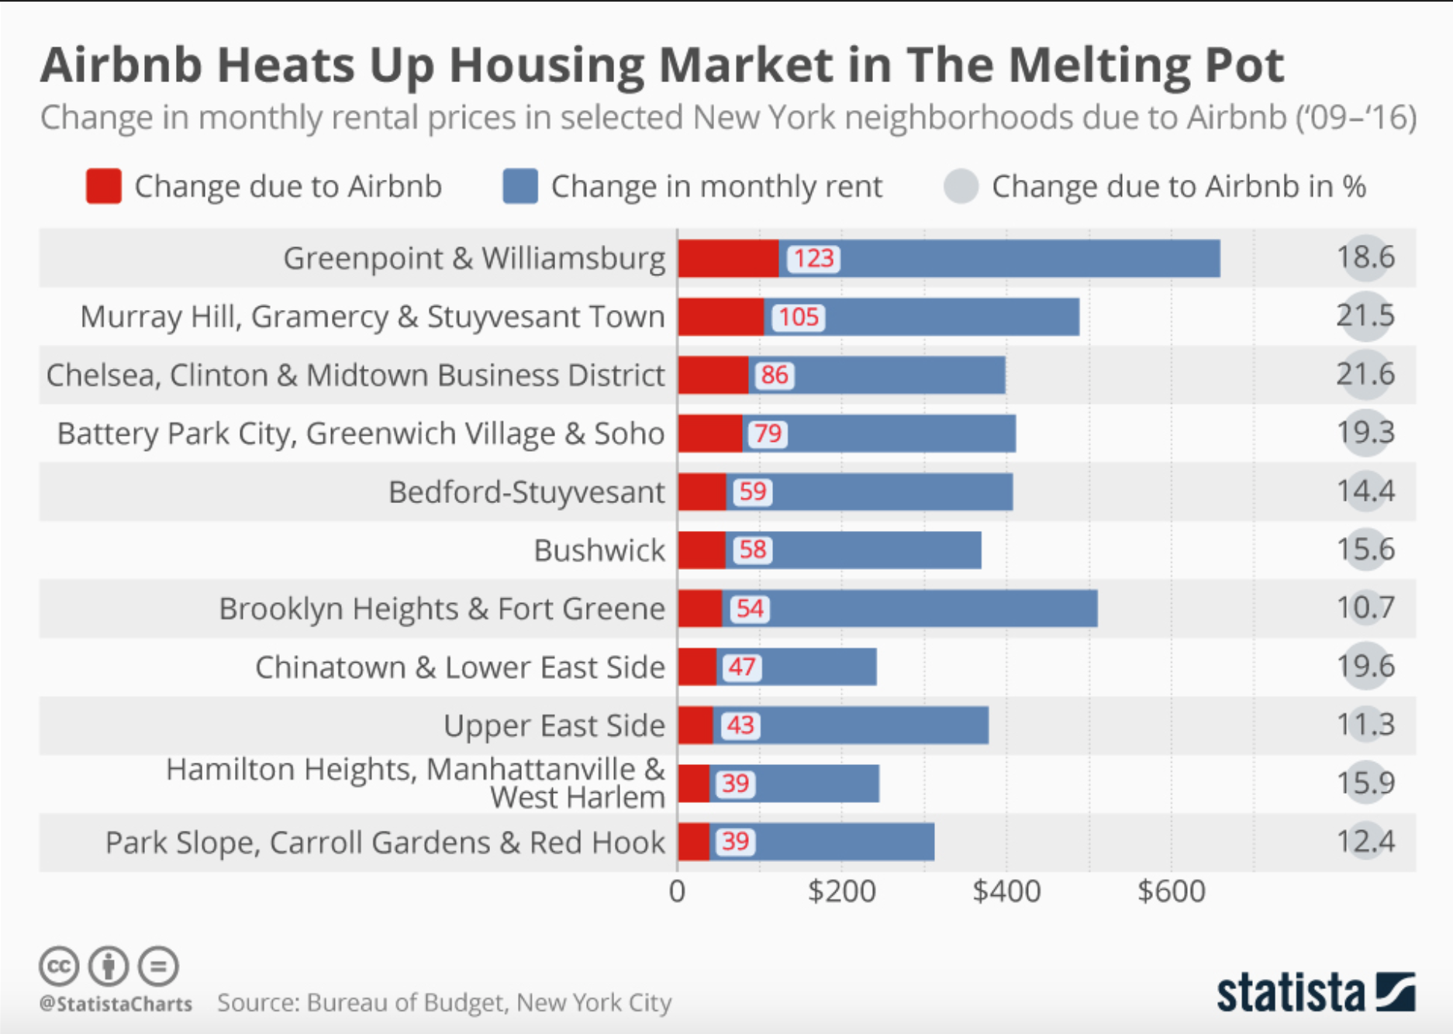non-existent or insignificant if there was a regulation in place to limit Airbnb.

*Figure 1 (Statista, 2020)*

From this analysis of the impact of Airbnb on the housing market and more specifically rental prices, it allows us to connect this problem to a behavioral finance theory. The trend of converting property into short-term rental has become more and more common leading one to believe that herd investing could be occurring. Herd investing is a situation in which market participants react to information about the behavior of other market agents or participants rather than the behavior of the market, and the fundamental transactions. A great example of this occurring can be seen in Airbnb’s referral program. According to Airbnb, the Host Referral Program permits select, invited eligible members to earn money by referring to Airbnb first time, new Hosts who create listings or activate existing listings for the first time and successfully complete bookings (Airbnb, 2020). A “Completed” booking is a booking that is accepted by the Referred Host and paid for by the Guest and which is not cancelled by either the Guest or the Referred Host at any time before or after the scheduled check-in for such booking (Airbnb, 2020). Through this referral program that Airbnb has implemented, it has created this community of herd investing. When new hosts react and act on the information and referral from other hosts based on their positive experiences, a herd of new participants is created. The reason this could lead to herd investing is because in a referral program, the people giving out referrals are the ones that love the product or idea. Referral programs are one sided in nature because if a person does not like the product or idea, they are not likely to refer another person to it. It is the individuals who have nothing but great things to say about it that are the ones who refer the platform to their family and friends. Since potential hosts are being referred to by the biased majority, the likelihood that they will list their properties is significantly large. Throw in some monetary incentives with it and it seems like a no brainer. The setup of Airbnb and its referral program breeds herd investing.

The reason this is a concern is because herding has a history of starting large, unfounded market rallies and sell-offs that often lack fundamental support to justify the transaction. Herd instinct is a significant driver of asset bubbles in financial markets (Investopedia, 2020). A great example of this is the dotcom bubble that plagued the world in the 1990s and early 2000s. These types of bubbles occur when exuberant market behavior drives a rapid escalation in the price of an asset above and beyond its intrinsic value (Investopedia, 2020). The bubble continues to inflate until the asset price reaches a level beyond fundamental and economical rationality (Investopedia, 2020). At this stage in a bubble’s existence, further increases in the cost of the asset occur because investors continue to buy in at high prices (Investopedia, 2020). When investors are no longer willing to buy at that price level, the bubble begins to collapse. In speculative markets, the burst can incite far-reaching corollary effects (Investopedia, 2020).

This idea can further be seen with the impact it is having on the housing market. In a study conducted by the Economic Policy Institute it is proclaimed that, “While the introduction and expansion of Airbnb into cities around the world carries large potential economic benefits and costs, the costs to renters and local jurisdictions likely exceed the benefits to travelers and property owners.” (Forbes, 2020). The negative economic impacts have created this issue termed the ‘Airbnb Effect’. The Airbnb effect consists of these unforeseen side-effects that Airbnb is having on the local economy and local real estate. Similar to the herding effect discussed above, the Airbnb effect is leading to this idea of gentrification. Gentrification, according the Webster Dictionary, is a process in which a poor area (as of a city) experiences an influx of middle-class or wealthy people who renovate and rebuild homes and businesses, and which often results in an increase in property values and the displacement of earlier, usually poorer residents (Merriam Webster, 2020). When applied to Airbnb’s case the similarities are seen in that, the ‘Airbnb effect’ is to some extent [remarkably similar to gentrification](https://www.researchgate.net/publication/307554257_Holiday_Rentals_The_New_Gentrification_Battlefront) in that it slowly increases the value of an area to the detriment of the indigenous residents, many of whom are pushed out due to financial constraints (Forbes, 2020). This effect is having the biggest impact on large, popular cities. Destinations like Amsterdam and Los Angeles have discovered that the over-tourism being facilitated by online platforms like Airbnb are having severe impacts on the housing prices and surrounding communities.

The process of gentrification is hurting the local economy as landlords are repurposing their units and properties that would normally be used to sell or long-term rent, to now fit the purposes of short-term rentals. As this occurs, the prices of homes naturally increase making it harder for young families to invest into real estate. In Boston, “a one standard deviation increase in Airbnb listings … relative to total housing units is correlated with a 5.9 percent decrease in the number of rental units offered for rent.” (Bloomberg, 2020). The shift to converting property into short-term listings is taking available property off the market to buy, thus making it that much harder for families to find affordable homes to purchase.

With the disruptive nature that Airbnb is having on the housing market, it forces us to ask the question of whether or not Airbnb cares about the community, or if they are only concerned with their bottom line and executive stock performance. This is important to evaluate because if a company is having such a strong influence on the pricing of homes to the point where communities are being damaged, then maybe they should adjust their strategy to better meet the needs of people. In Figure 2 shown below, you can see a gradual shift in increase that CEO’s have seen in their pay over the last 15 years. Although this chart is slightly outdated it can be inferred that these trends have only continued to increase over time. This graph which is taken from a supplemental reading from the course can be directly tied to the problem being discussed with Airbnb. It may be fair to assume that if a company like Airbnb is focused on maximizing compensation of the top-level executives, that it might inadvertently have a negative effect on the global housing economy. It leads one to believe that Airbnb’s greed may be dangerous to communities all around the world. This is further discussed in a supplemental reading where it is stated that, “Despite all the structural forces aiding companies’ bottom lines and stock prices, boards continue to act as if C.E.O.s have unique powers to deliver better returns — and have gone to great lengths to compensate them.” (Eavis, 2018). So as Airbnb continues to grow and expand it can only be assumed that Airbnb will 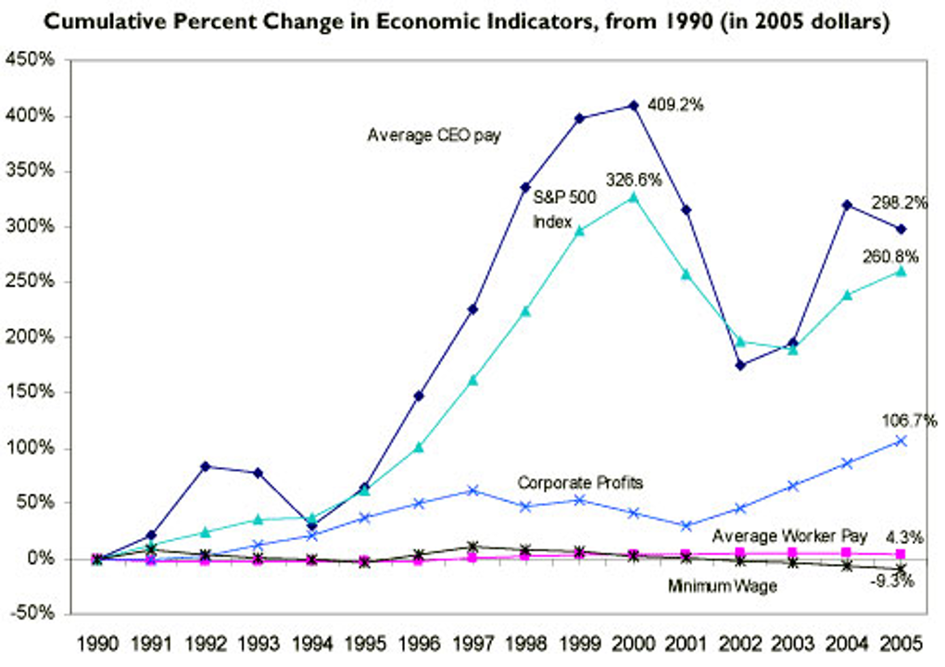continue compensating their top-level executives as if they have managerial superpowers, which might further this negative trend.

*Figure 2. Supplemental Reading: CEO Compensation*

Through all of these examples presented above regarding the business and economic effect that Airbnb is inadvertently having, it becomes evident that change needs to be made. Families are the ones struggling with the effects of Airbnb’s money-driven model in the form of increased rent or housing shortages. This problem, which started out as small, is now being seen globally. If Airbnb continues to grow and expand at its current rate with no significant changes, the housing and renting economy for middle- and lower-class individuals may find itself in big trouble.

**Government-Related Issues:**

While Airbnb was meant to be a platform for individuals to rent out their properties and spare bedrooms to short-term renters in need of somewhere to stay, it has morphed itself into a much larger and harder-to-regulate monster. In the past few years as Airbnb has gained popularity, there has been an increasing number of large entities such as hotel companies that have been listing their properties on the real estate-sharing platform in hopes of getting around the tax that is levied against them by traditional hotel tax laws. While its original use was harmless, the inclusion of these professional users may be costing the United States government large sums of tax dollars and represents an already-troubling trend of tax avoidance and evasion in the country.

When entrepreneurs get together to create a company, they are usually trying to fix an issue that society has. However, in the process of making such repairs, they may be negatively impacting other areas of life. We believe that this is the case with Airbnb. While they have allowed individuals to create income through single-room or whole-house rentals, they have also created a space where tax avoidance, and potentially evasion, can occur.

Hotel tax laws can be on city, county, or state levels and will differ from place to place. For example, in Los Angeles County, there is a 12% tax that is levied on hotels and motels for renting out rooms. In the state of Texas, there is a 6% tax on hotel rooms. In New York City, there is a $1.50 tax due per unit rented, along with all other applicable hoteling taxes. As Airbnb came along, an opportunity arose for hoteling companies to work around the taxes and fees they were facing. By listing their rooms and properties on this new, unregulated platform, a hotel chain could potentially avoid having to pay these fees and thus increase their profits despite the potential detrimental effect on the general public.

While this use case of Airbnb might seem to be a theoretical case, *New York Times* reporter David Streitfeld took a look into Airbnb listings, specifically focusing on New York City given the trove of data available for listings in the area. If the postings on Airbnb were legitimate and followed all zoning, local, state and federal laws, then there would be no issue and the postings would cause no harm. However, in the article, he highlights specific numbers that might cause one to be concerned. In his report, he finds that “nearly three quarters of all Airbnb rentals in the city are illegal, violating zoning or other laws,” (Streitling, 2014). He goes on to say that the commercial operators make up almost a third of all units being listed on Airbnb in the city. For each of these units, perpetrators may be costing taxpayers at least $1.50 per room per night. Given the high quantity of units and the potentially unlimited period of time for this to go on, there are millions and millions of dollars of taxpayer money potentially at stake in this situation.

Specific care should be shown to this general area given the sheer volume of rentals that are operated by multiple-lister hosts. In their research, which analyzes the social and economic impact of Airbnb on New York City, faculty from a prominent Central European higher education institution, the University of Szeged, attempted to quantify what the home-sharing platform can do to an economy. One aspect of their research took a look at the revenue being generated by individuals who hosted multiple listings (hereby referred to as multiple-lister hosts). After combing through all the data they had from Airbnb and the US Census, as well as previous research done in the area, they were able to confirm and conclude that while “multiple hosts represent only 6 percent of Airbnb hosts...they dominate the platform and generate 37 per cent of all host revenues [in New York City], receiving $168 million,” (Dudás, 2017). While we are not implying that this entire chunk of revenue is being generated in an attempt to evade or avoid taxes, we are implying that the potential for this type of activity is very high, and that regulators must take a serious look at the laws and regulations surrounding Airbnb to ensure that local governments aren’t losing millions of dollars in potential tax revenue. This negative externality should raise red flags with regulators across the country.

Airbnb’s impact was further researched in a study conducted by Boston University and University of Southern California faculty, this time with a specific focus on the effect that a hotel’s use of Airbnb can have on governments and economies. Specifically, they focused on the state of Texas. In their conclusion, they made a clear message to policy makers about the tax implications of Airbnb, saying “With demand shifting away from [well-regulated industries like hotels], and to the extent that regulation and taxation of peer-to-peer platforms proves to be more challenging, the bottom line of cities with an established Airbnb presence could be hurt in the short run,” (Byers, 2013). The amount of business flocking from traditional businesses to new, unregulated industries, lawmakers need to ensure that the tax code is properly applied to the revenue that originates from these platforms. If they fall behind on this issue, it could end up costing local governments significant tax dollars.

Unfortunately, American businesses have not provided the government with much reason to trust them, as there has been an unwillingness and reluctance to pay taxes since the birth of this country. Tax avoidance has often been employed as a strategy for businesses to maximize their wealth, which has in turn reduced the government’s ability to keep up with the needs of the people given their potentially constrained budgets.

While individuals trying to evade taxes is a concern, the amount of taxes they are paying are far less impactful than the amount of taxes that corporations are paying. Large companies like Apple and Amazon are generating billions and billions of dollars’ worth of revenue, but have found ways to drastically reduce their tax bills to the disadvantage of the general public. Andrew Sorkin of the New York Times went through the research reports based around the profits of Fortune 500 companies and found that “If all the Fortune 500 companies paid taxes on their sheltered profits, the researchers tallied, the government would receive a whopping $717.8 billion…” (Sorkin, 2016). To put that number into context, the government deficit in 2015 was $438 billion. If corporations paid full tax on their sheltered profits, the government would be running a surplus instead of a deficit. The magnitude of this issue makes a difference, and thus must be taken seriously.

This trend is not just seen in relations with the United States government, however, as large corporations who operate in multiple countries often attempt to create complicated, international strategies to dance around the tax codes of different countries. As Stephen Wilmot of the *Wall Street Journal* discusses in one of this quarter’s supplemental readings, the government is aware of these activities and is actively trying to stop these companies from continuing on this path, pointing out that “The U.S. Treasury issued rules that force all U.S. multinationals with revenues above $850 million to file country-by-country returns for financial years starting after June 30,” (Wilmot, 2016). In an attempt to help the IRS and other governments track corporate profits more accurately, the United States government has forced its large, multinational corporations to create clear and orderly records. A measure like this has been put in place because corporations try to wiggle their way out of paying any tax that they don’t have to. This new requirement will hopefully allow federal tax entities to more efficiently and effectively review the tax returns of these conglomerates and thus provide governing agencies more money to run effective programs.

The previous two paragraphs serve as a reminder of how big of an issue tax avoidance is in the United States and in the world. The numbers being thrown around are in the hundreds of billions, if not trillions, and have the potential to impact millions of people throughout the country and the world. While these specific issues don’t specifically apply to Airbnb, they show a general trend of shady behavior and disobedience around the realm of tax, which makes it entirely feasible that some of these corporations in the hotel industry would attempt to use Airbnb and its platform as a tool that may help them avoid paying certain taxes that are levied on them.

We have found no evidence that Airbnb has been practicing these types of tactics and haven’t found evidence that they are encouraging this type of behavior specifically, either. There is evidence, however, that Airbnb’s platform is being used illegally and inappropriately by hotel companies to avoid tax and that there is a storied history of American companies avoiding large tax bills. This combination is a recipe for tax avoidance and evasion and must be met with proper regulation. It’s important to note that while the numbers involved with Airbnb might not be as large as some of the numbers described above, it is important to set a strong precedent and stick to normal procedures so that the tax law will be properly applied to all in an equal and fair fashion.

The next step in this process is figuring out how to properly regulate Airbnb in a way that minimizes the amount of tax evasion and allows for proper tax avoidance for the activities that the government deems as beneficial to the economy. Such tax laws will be difficult to pass through congress and heavily disputed on a state-by-state and county-by-county level. To deal with the dissent that might come with such a proposition, more research needs to be done on the proper way to regulate Airbnb, along with other “Sharing Economy” businesses, in order to find realistic laws and regulations that can easily be applied and enforced equally throughout the country. Ideally, the legislature will push Airbnb to be more involved with classifying hosts as professional organizations or individuals and to maintain a clear “paper trail” (which will most likely be digital) so they can provide hosts and the government with proper documentation that captures the transactions that are taking place so they can easily be applied to tax documents.

**Conclusion:**

Airbnb’s unregulated business activity has led to a complex web of issues including neighborhood disruption (social), rent inflation and gentrification (economic) and tax evasion (governmental). All these dilemmas, when analyzed under the lens of ethical theories such as Rawl’s veil of ignorance and act utilitarianism, deem Airbnb’s actions to be morally wrong. Moreover, this has caused investors to rethink their investment into Airbnb due to changing behaviors under theories such as emotional bias and herd investing. Finally, by analyzing the issue at hand via case studies and articles such as ‘the truth about CSR’, ‘it’s never been easier to be CEO’, ‘when it comes to tax avoidance’ and ‘multinational tax avoidance crackdown’, it is clear than Airbnb needs to be better regulated in order to be held accountable for its actions. We advocate that Airbnb be subject to the hotel tax rate; Airbnb is an accommodation provider offering services similar to those of a hotel, therefore subjecting them to the same taxes is a logical next step. Furthermore, we advocate that Airbnb be required to register all listings with their respective municipalities and transmit all individual income data to the relevant authorities. Keeping accurate records is critical to preventing illegal listings and behavior such as tax evasion. Finally, we strongly advocate for Airbnb to develop a worldwide marketing campaign detailing the positive externalities of its business activity. Airbnb must educate the public on all of its impacts to appease stakeholders. Implementing the above solutions leads to a just compromise for all parties and will allow for a healthier, more collaborative relationship amongst stakeholders as Airbnb continues to expand in the future.

Works Cited

Airbnb Increases Home Prices. (n.d.). Retrieved November 23, 2020, from https://www.bloomberg.com/news/articles/2019-02-01/airbnb-increases-home-prices-yet-escapes-regulation

Barker, G. (2020, February 21). The Airbnb Effect On Housing And Rent. Retrieved November 19, 2020, from https://www.forbes.com/sites/garybarker/2020/02/21/the-airbnb-effect-on-housing-and-rent/?sh=5a4372aa2226

Byers, John, et al. “The Rise of the Sharing Economy: Estimating the Impact of Airbnb on the Hotel Industry.” *SSRN Electronic Journal*, 2013, doi:10.2139/ssrn.2366898.

Chen, J. (2020, August 28). Herd Instinct Definition. Retrieved November 28, 2020, from https://www.investopedia.com/terms/h/herdinstinct.asp

Dean, James. “Riot Police Called to Airbnb Party.” News | The Times, The Times, 14 May 2016, www.thetimes.co.uk/article/riot-police-called-to-airbnb-party-whxgln9hx.

Dudás, Gábor, et al. “A Socio-Economic Analysis of Airbnb in New York City.” *Regional Statistics*, vol. 7, no. 1, 2017, pp. 135–151., doi:10.15196/rs07108.

Eavis, P. (2019, May 24). It's Never Been Easier to Be a C.E.O., and the Pay Keeps Rising. Retrieved November 30, 2020, from https://www.nytimes.com/2019/05/24/business/highest-paid-ceos-2018.html

Folger, J. (2020, August 28). Airbnb: Advantages and Disadvantages. Retrieved November 23, 2020, from https://www.investopedia.com/articles/personal-finance/032814/pros-and-cons-using-airbnb.asp

Gentrification. (n.d.). Retrieved November 28, 2020, from https://www.merriam-webster.com/dictionary/gentrification

History of Airbnb. (2016, December 16). Retrieved November 23, 2020, from https://airbnb370.wordpress.com/history-of-airbnb/

Kyle Barron, . (2019, April 17). Research: When Airbnb Listings in a City Increase, So Do Rent Prices. Retrieved November 19, 2020, from https://hbr.org/2019/04/research-when-airbnb-listings-in-a-city-increase-so-do-rent-prices

Marcelle, Annie. “My Neighbors Killed My Airbnb Unit - Tips to Stay Safe.” LearnBNB.com - Hosting Advice, Tips, &amp; Resources, 11 Dec. 2019, learnbnb.com/neighbors-killed-airbnb-unit/.

Nichols, Barbara. “Is Airbnb Ruining Neighborhoods?” Vivi Bene Realty Services, 20 Sept. 2016, vivibenerealty.com/2016/09/20/airbnb-ruining-neighborhoods/.

Parker, Tim. “Cognitive vs. Emotional Investing Bias: What's the Difference?” Investopedia, Investopedia, 28 Aug. 2020, www.investopedia.com/articles/investing/051613/behavioral-bias-cognitive-vs-emotional-bias-investing.asp.

Rangan, V. Kastur and Sohel Karim. “The Truth About CSR.” Harvard Business Review, 9 Mar. 2015, hbr.org/2015/01/the-truth-about-csr.

Rental Price Change in NYC. (n.d.). Retrieved from https://www-statista-com.ezproxy.lib.calpoly.edu/chart/13755/rental-price-change-in-nyc-due-to-airbnb/

Report • By Josh Bivens • January 30. (n.d.). The economic costs and benefits of Airbnb: No reason for local policymakers to let Airbnb bypass tax or regulatory obligations. Retrieved November 19, 2020, from https://www.epi.org/publication/the-economic-costs-and-benefits-of-airbnb-no-reason-for-local-policymakers-to-let-airbnb-bypass-tax-or-regulatory-obligations/

Sorkin, Andrew Ross. “When It Comes to Tax Avoidance, Donald Trump's Just a Small Fry.” *The New York Times*, The New York Times, 4 Oct. 2016, www.nytimes.com/2016/10/04/business/dealbook/when-it-comes-to-tax-avoidance-donald-trumps-just-a-small-fry.html.

Streitfeld, David. “Airbnb Listings Mostly Illegal, New York State Contends.” The New York Times, Technology, Oct. 15, 2014. https://www.nytimes.com/2014/10/16/business/airbnb-listings-mostly-illegal-state-contends.html?module=inline

Wilmot, Stephen. “Multinational Tax Avoidance Crackdown Goes Far Beyond Apple.” *The Wall Street Journal*, Dow Jones & Company, 20 Sept. 2016, www.wsj.com/articles/multinational-tax-avoidance-crackdown-goes-far-beyond-apple-1474371392.

“Original Position.” Wikipedia, Wikimedia Foundation, 12 Nov. 2020, en.wikipedia.org/wiki/Original_position.